University of Phoenix Material

Programming Assignment Worksheet

To: Troy Tucket
From: Learning Team C: Timothy Fletcher-Justin Amescua-Elbio Iseas-Leif Rebuck-Michelle Patino
Date: 11/28/2015
Assignment: Theatre seating program

Requirements:

.
Design:
The TheaterSeatingProgram.cpp C++ console application achieves its goal with a procedural programming approach. The idea is to provide the user with a console application for selling tickets for a small theater. The system will save the seats sold and available to disk with the help of two text files: “theaterseats.txt”, and a backup text file “backuptheaterseats.txt”.
The program will start by looking for the file “theaterseats.txt”, if it does not find the file, it will create it and it will save 100% availability of seats from information stored in ten char arrays named row1…row0. If the file exists it will read the file into these arrays. At the exit of the program a module will save the content of these arrays to the text file “theaterseats.txt”, and “backuptheaterseats.txt” for backup. If something goes wrong, and it cannot save the values of the arrays to disk, the backup file will be available for making a copy with the name of the file “theaterseats.txt”.
The main menu has five choices and an exit choice which can be selected by pressing “0” or the key “ESC”. The other choices are:
- Selling tickets,
- Total of all tickets sales,
- List of sold tickets,
- Available seats per row,
- Available seats in auditorium
- Exit the program [ Esc ].
There is a sentinel boolean variable named “soldOut” which is checked for its status every time the user enters an option from the menu. If there are no available seats at all in the theater for selling, the value of the variable should be true and the program will display a message saying “All the seats in the theater are sold out.” Giving the user the chance to press any key and come back to the main menu.
Also, there is an array for storing available seats per row in the auditorium with the name “auditoriumSeats[]”, type int. Another array type double with ten elements keeps the prices per row, “seatPricesByRow[]”.
At the beginning of the program there is a welcome screen with the name of the program and the names of the Learning Team C members. After the user press any key to start the program, an intro() module will give the effect of theater opening curtain, and it will stay open until the end of the program.
On the first screen, on the top left half screen will appear “M A I N M E N U” inside a box, and on the same side at the bottom the two lines box for communication between the user and the program. At the same time on the left side of the screen it will appear the choices for the main menu, and on the right side of the screen it will be the seat availability chart. This chart which is updated at all time for its seat availability shows a matrix where the name of the rows are listed on the left, and the numbers of the columns or seat numbers on top. The possible symbols for this chart are a “#” for available or “*” for taken or sold.
The first entry of the menu allows the user to sell any available seat in the theater. It starts asking for the row number from 0-10 and if the user wants to finish, he/she can do it by entering a “0” and pressing [Enter]. The program is built to allow only a number from 0 to 10. It will not accept a number out of that range. If the number entered is different from zero, the program will ask for entering a seat number always from 1-10. The same policy in this case, valid numbers only from 1-10.
The program will check the availability of that seat, and if it is available , it will show a message with the price of the location. It will also ask for confirmation of the sale. There is a confirmation module “char confirm()” that will ask for a response from the user, allowing only the following characters “YnNn”. If the user confirms the sale by pressing “Y” or “y”, then a module will update the chart (array) and refresh the availability chart on screen.
The user will remain in the loop of entering a row number while there are still available seats and he/she does not press “0” for returning to the main menu.
The second entry will display row by row the amount in $ for sales, and with the total at the end of the last row.
The third entry will display by row the number of the seats sold.
The fourth entry will show row by row the number of the seats available.
The fifth entry will show number of seats available per row, and the sum of available seats at the end of the rows.

- Define Globals.
- Program execution from Main Method:
  - Loads information from the storage system text file.
  - Sets the color to Blue.
  - Displays the introduction screen.
    - Waits for any key to proceed.
  - Displays the main menu screen.
    - Accepts and evaluates user input and directs application to appropriate module.
  - Passes user selection to control switch:
      - Selling Tickets
        - Display seating chart
        - User input: Choose a Row
        - User input Choose a Seat
          - Process seat selection
            - If 0, exit to main menu
            - If valid seat selection:
              - Alert seat sold, reset window
              - Display price of seat, confirm purchase
                - If yes update sale in charts, and sales. Reset window.
                - If no, reset window.
      - Total of all ticket sales
        - Calculate and display seat sales for each row.
        - Calculate and display total seat sales.
        - User Input: Any key returns to Main Menu.
      - List of sold tickets
        - Display chart showing seats sold.
        - User Input: Any key returns to Main Menu.
      - Available Seats per Row
        - Display chart showing available seats in each row.
        - User Input: Any key returns to Main Menu.
      - Available Seats in Auditorium
        - Display chart showing quantity of seats available in each row.
        - User Input: Any key returns to Main Menu.
- Exit the Program
- End of Main Method and program

- Global definitions:
- Define char array for each row, initialized to “#” (row1-row0)
- Define int array for seats per row (auditoriumSeats)
- Define double array for seat prices for each row (seatPricesByRow)
- Define double array to store sales for each row (soldPerRow)
- Define Boolean variable representing seat availability (soldOut)
- Define Function, no return, loop delay in mSecs (sleep)
- Define Function, no return, cursor positioning (gotoxy)
- Define Function, no return, message display (say)
- Define Function, no return, clears the screen (clearscreen)
- Define Function, no return, applies pattern for borders (drawboxborder)
- Define Function, no return, draws a box based on symbol passed as argument (paintbox)
- Define Function, no return, reads seat data from file (readFromFile
- Define Function, no return, saves seat data to a text file (saveToFile)
- Define Function, returns char, operation confirmation (confirm)
- Define Function, no return, updates seat from # to * when selected (updateLocation)
- Define Function, no return, displays seat availability per row (displaySeats)
- Define Function, no return, update seat status (refreshChart)
- Define Function, returns bool, updates status of soldOut when sold out(soldOutSeats)
- Define Function, returns bool, checks seat availability (available)
- Define Function, returns int, main menu control loop, sentinel initialized to 54 (chooseTask)
- Define Function, returns int, accepts user input for seat selection. (readSeatToSell)
- Define Function, returns int, user input for range of row(readRow)
- Define Function, no return, allows user to select a seat for purchase (tickets)
- Define Function, no return, calculates total ticket sales(totalTicketSales)
- Define Function, no return, display sales for each row and total (totalTickets)
- Define Function, no return, display available seats per row (seatsAvailabilityperRow)
- Define Function, returns int, calculates available seats per row(availableSeatsPerRow)
- Define Function, no return, display available seats in auditorium (seatsAvailinAuditorium)
- Define Function, no return, display the main menu (displayMenu)
- Define Function, no return, display the program introduction (intro)
- Define Function, no return, delay loop (sleep)
- Define Function, no return, draws the seat availability chart (drawChart)
Source Programs:
// =====================================================================================
// TheaterSeatingProgram.cpp : Defines the entry point for the console application.
// Author : Learning Team C - University of Phoenix 2015 -
// Timothy Fletcher, Justin Amescua, Elbio Iseas, Leif Rebuck, Michelle Patino
// =====================================================================================
#include "stdafx.h"
#include <iostream>
#include <iomanip>
#include <conio.h>
#include <array>
#include <cstdlib>
#include <stdlib.h>
#include <ctime>
#include <string>
#include <windows.h>
#include <fstream>

#define ESC 27

using namespace std;

// =====================================================
// theater seat availability by row from row 1 to 10
// =====================================================
char row1[] = { '#', '#', '#', '#', '#', '#', '#', '#', '#', '#' };
char row2[] = { '#', '#', '#', '#', '#', '#', '#', '#', '#', '#' };
char row3[] = { '#', '#', '#', '#', '#', '#', '#', '#', '#', '#' };
char row4[] = { '#', '#', '#', '#', '#', '#', '#', '#', '#', '#' };
char row5[] = { '#', '#', '#', '#', '#', '#', '#', '#', '#', '#' };
char row6[] = { '#', '#', '#', '#', '#', '#', '#', '#', '#', '#' };
char row7[] = { '#', '#', '#', '#', '#', '#', '#', '#', '#', '#' };
char row8[] = { '#', '#', '#', '#', '#', '#', '#', '#', '#', '#' };
char row9[] = { '#', '#', '#', '#', '#', '#', '#', '#', '#', '#' };
char row0[] = { '#', '#', '#', '#', '#', '#', '#', '#', '#', '#' };
// ===============================================
// theater seat availability in the Auditorium
// ===============================================
int auditoriumSeats[] = { 10, 10, 10, 10, 10, 10, 10, 10, 10, 10 };
// =====================================================================================
// Seat prices by row # : 1 2 3 4 5 6 7 8 9 10
// =====================================================================================
double seatPricesByRow[] = { 60.00, 55.00, 50.00, 45.00, 40.00, 35.00, 30.00, 25.00, 20.00, 15.00 };
// =========================================================
// array to keep the dolar amount of tickets sold by row
// =========================================================
double soldPerRow[] = { 0.00, 0.00, 0.00, 0.00, 0.00, 0.00, 0.00, 0.00, 0.00, 0.00 };
// ============================================================
// boolean soldOut sentinel for when all seats are sold out
// ============================================================
bool soldOut = false;
// =============================================================
// function to delaying a loop in miliseconds as an argument
// =============================================================
void sleep(unsigned int);
// ============================================================================================================
// https://msdn.microsoft.com/en-us/library/windows/desktop/ms686025(v=vs.85).aspx
// result of the online research for the old C language function for positioning the cursor
// The purpose of this function is to position the cursor on screen
// so there is no need to use endl or leading blanks
// ============================================================================================================
void gotoxy(int x, int y) // function with the two int parameters x, and y for column, and row respectively
{
HANDLE hStdOut = GetStdHandle(STD_OUTPUT_HANDLE);
COORD coord; // it creates an object COORD named coord for the screen coordinates
coord.X = x; // it assigns the value of the parameter x (column) to the object coord.X
coord.Y = y; // it assigns the value of the parameter y (row) to the object coord.Y
SetConsoleCursorPosition(hStdOut, coord); // it sets the cursor position with the values of the object coord
}
// ========================================================================================
// this function displays a message or character in the x, y coordinates of the console
// x is the column argument to display the message
// y is the line argument to display the message
// message is the argument you want to display at the coordinates x, y
// ========================================================================================
void say(int x, int y, string message)
{
gotoxy(x, y);
cout << message;
}
// =========================================================
// this function when called it clear the console screen
// it uses the system OS command CLS
// =========================================================
void clearscreen()
{
system("CLS");
}
// ==================================================================
// this function makes the border of a box with five parameters :
// top left screen column coordinate
// top left screen line coordinate
// bottom right screen column coordinate
// bottom right screen line coordinate
// the parameter symbol can have one of three possible values
// 0 for blank
// 1 for single line
// 2 for double line
// ===========================================================================
void drawboxborder(int x1, int y1, int x2, int y2, int symbol)
{
string topleftcorner,
toprightcorner,
bottomleftcorner,
bottomrightcorner,
topsymbol,
bottomsymbol,
leftsymbol,
rightsymbol;

if (symbol == 0)
{
topleftcorner = " ";
toprightcorner = " ";
bottomleftcorner = " ";
bottomrightcorner = " ";
topsymbol = " ";
bottomsymbol = " ";
leftsymbol = " ";
rightsymbol = " ";
}
else if (symbol == 1 || symbol == 2)
{
topleftcorner = (symbol == 1) ? "Ú" : "É";
toprightcorner = (symbol == 1) ? "¿" : "»";
bottomleftcorner = (symbol == 1) ? "À" : "È";
bottomrightcorner = (symbol == 1) ? "Ù" : "¼";
topsymbol = (symbol == 1) ? "Ä" : "Í";
bottomsymbol = (symbol == 1) ? "Ä" : "Í";
leftsymbol = (symbol == 1) ? "³" : "º";
rightsymbol = (symbol == 1) ? "³" : "º";
}

if (symbol >= 0 && symbol <= 2)
{
int col, line;

say(x1, y1, topleftcorner);
say(x2, y1, toprightcorner);

for (col = x1 + 1; col <= x2 - 1; col++)
say(col, y1, topsymbol);
for (line = y1 + 1; line <= y2 - 1; line++)
{
say(x1, line, leftsymbol);
say(x2, line, rightsymbol);
}

say(x1, y2, bottomleftcorner);
say(x2, y2, bottomrightcorner);

for (col = x1 + 1; col <= x2 - 1; col++)
say(col, y2, bottomsymbol);
}
}
// ===========================================================================
// this function paints a screen box with the symbol passed as an argument
// x1 is the left column value of the top left corner
// y1 is the top line value for the top left corner
// x2 is the right column value of the bottom right corner
// y2 is the bottom line value of the bottom right corner
// symbol is the character you pass as argument to fill the box
// ===========================================================================
void paintbox(int x1, int y1, int x2, int y2, string symbol)
{
int col, line;
for (line = y1; line <= y2; line++)
{
for (col = x1; col <= x2; col++)
say(col, line, symbol);
}

}
// ==========================================================
// module for reading file with available and taken seats
// ==========================================================
void readFromFile()
{
ifstream textFile; // it creates a input file named textFile

textFile.open("theaterseats.txt"); // it opens the file with the physical name "theaterseats.txt"

if (textFile.fail()) // if it fails to open the file executes the block
{

ofstream textFile; // it creates an output file named textFile

textFile.open("theaterseats.txt"); // it opens the file with the physical name "theaterseats.txt"

textFile << row1; // saves the array row1 to disk
textFile << row2; // saves the array row2 to disk
textFile << row3; // saves the array row3 to disk
textFile << row4; // saves the array row4 to disk
textFile << row5; // saves the array row5 to disk
textFile << row6; // saves the array row6 to disk
textFile << row7; // saves the array row7 to disk
textFile << row8; // saves the array row8 to disk
textFile << row9; // saves the array row9 to disk
textFile << row0; // saves the array row0 to disk

textFile.close(); // it closes the file
}
else // if the files exists it executes the next block
{

char line[100]; // it creates a char array of 100 elements, named line
char aChar = ' '; // it creates a char variable named aChar

ifstream textFile; // it creates an input file name textFile

textFile.open("theaterseats.txt"); // it opens a file named "theaterseats.txt"

for (int i = 0; i < 100; i++) // if runs a for loop of 100 cycles
{
textFile.get(aChar); // it gets a char from the file into the variable aChar
line[i] = aChar; // it assigns that char to the char array line
}
for (int i = 0; i < 10; i++) // it runs a for loop of 10 cycles
{
row1[i] = line[i]; // it loads a specific char from the line array into the row arrays
row2[i] = line[i + 10]; // it loads a specific char from the line array into the row arrays
row3[i] = line[i + 20]; // it loads a specific char from the line array into the row arrays
row4[i] = line[i + 30]; // it loads a specific char from the line array into the row arrays
row5[i] = line[i + 40]; // it loads a specific char from the line array into the row arrays
row6[i] = line[i + 50]; // it loads a specific char from the line array into the row arrays
row7[i] = line[i + 60]; // it loads a specific char from the line array into the row arrays
row8[i] = line[i + 70]; // it loads a specific char from the line array into the row arrays
row9[i] = line[i + 80]; // it loads a specific char from the line array into the row arrays
row0[i] = line[i + 90]; // it loads a specific char from the line array into the row arrays
}

textFile.close(); // it closes the file textFile
}

textFile.close(); // it closes the file textFile

}
// ================================
// module to save seats to file
// ================================
void saveToFile()
{
ofstream textFile; // it creates an output file named textFile

textFile.open("theaterseats.txt"); // it opens the file with the physical name "theaterseats.txt"

textFile << row1; // saves the array row1 to disk
textFile << row2; // saves the array row2 to disk
textFile << row3; // saves the array row3 to disk
textFile << row4; // saves the array row4 to disk
textFile << row5; // saves the array row5 to disk
textFile << row6; // saves the array row6 to disk
textFile << row7; // saves the array row7 to disk
textFile << row8; // saves the array row8 to disk
textFile << row9; // saves the array row9 to disk
textFile << row0; // saves the array row0 to disk

textFile.close(); // it closes the file textFile

ofstream backupFile; // it creates an output file named backupFile

backupFile.open("backuptheaterseats.txt"); // it opens this file for writing and it gives the name "backuptheaterseats.txt"

backupFile << row1; // saves the array row1 to disk
backupFile << row2; // saves the array row2 to disk
backupFile << row3; // saves the array row3 to disk
backupFile << row4; // saves the array row4 to disk
backupFile << row5; // saves the array row5 to disk
backupFile << row6; // saves the array row6 to disk
backupFile << row7; // saves the array row7 to disk
backupFile << row8; // saves the array row8 to disk
backupFile << row9; // saves the array row9 to disk
backupFile << row0; // saves the array row0 to disk

backupFile.close(); // it closes the file backupFile
}
// ======================================
// module for confirming an operation
// it returns a char Y/y/N/n
// ======================================
char confirm()
{
char resp = ' '; // it creates a char variable and initializes with blank

while (resp != 'Y'&& resp != 'y'&& resp != 'N'&& resp != 'n') // it will keep in the while loop until resp is Y/y/N/n
{
say(42, 22, " "); // it displays a blank at 10,18
gotoxy(42, 22); // it moves the cursor to the coordinates specified
resp = getch(); // it gets a character from them keyboard
cout << resp; // display that character on screen
}

return resp;
}
// ==========================================================
// module for updating the state of the seat to '*' Taken
// ==========================================================
void updateLocation(int rowNum, int seatNum)
{
switch (rowNum) // starts evaluating rowNum
{
case 1: // when row is 1
row1[seatNum - 1] = '*'; // it updates the availability of the seat
break; // it exits the switch statement
case 2: // when row is 2
row2[seatNum - 1] = '*'; // it updates the availability of the seat
break; // it exits the switch statement
case 3: // when row is 3
row3[seatNum - 1] = '*'; // it updates the availability of the seat
break; // it exits the switch statement
case 4: // when row is 4
row4[seatNum - 1] = '*'; // it updates the availability of the seat
break; // it exits the switch statement
case 5: // when row is 5
row5[seatNum - 1] = '*'; // it updates the availability of the seat
break; // it exits the switch statement
case 6: // when row is 6
row6[seatNum - 1] = '*'; // it updates the availability of the seat
break; // it exits the switch statement
case 7: // when row is 7
row7[seatNum - 1] = '*'; // it updates the availability of the seat
break; // it exits the switch statement
case 8: // when row is 8
row8[seatNum - 1] = '*'; // it updates the availability of the seat
break; // it exits the switch statement
case 9: // when row is 9
row9[seatNum - 1] = '*'; // it updates the availability of the seat
break; // it exits the switch statement
case 10: // when row is 10
row0[seatNum - 1] = '*'; // it updates the availability of the seat
break; // it exits the switch statement
default: // exception condition
{
say(4, 21, "Exception condition found."); // it displays the exception condition message
say(4, 22, "Press any key to continue ... "); // it displays the message to continue
getch(); // it waits for the user to press any key
}
}
}
// =========================================================================================
// this module displays the seats availability of a specific row received as an argument
// =========================================================================================
void displaySeats(int rownum)
{
int row;
switch (rownum)
{
case 1:
row = 3;
gotoxy(58, row);
cout << row1[0];
gotoxy(60, row);
cout << row1[1];
gotoxy(62, row);
cout << row1[2];
gotoxy(64, row);
cout << row1[3];
gotoxy(66, row);
cout << row1[4];
gotoxy(68, row);
cout << row1[5];
gotoxy(70, row);
cout << row1[6];
gotoxy(72, row);
cout << row1[7];
gotoxy(74, row);
cout << row1[8];
gotoxy(76, row);
cout << row1[9];
break;
case 2:
row = 5;
gotoxy(58, row);
cout << row2[0];
gotoxy(60, row);
cout << row2[1];
gotoxy(62, row);
cout << row2[2];
gotoxy(64, row);
cout << row2[3];
gotoxy(66, row);
cout << row2[4];
gotoxy(68, row);
cout << row2[5];
gotoxy(70, row);
cout << row2[6];
gotoxy(72, row);
cout << row2[7];
gotoxy(74, row);
cout << row2[8];
gotoxy(76, row);
cout << row2[9];
break;
case 3:
row = 7;
gotoxy(58, row);
cout << row3[0];
gotoxy(60, row);
cout << row3[1];
gotoxy(62, row);
cout << row3[2];
gotoxy(64, row);
cout << row3[3];
gotoxy(66, row);
cout << row3[4];
gotoxy(68, row);
cout << row3[5];
gotoxy(70, row);
cout << row3[6];
gotoxy(72, row);
cout << row3[7];
gotoxy(74, row);
cout << row3[8];
gotoxy(76, row);
cout << row3[9];
break;
case 4:
row = 9;
gotoxy(58, row);
cout << row4[0];
gotoxy(60, row);
cout << row4[1];
gotoxy(62, row);
cout << row4[2];
gotoxy(64, row);
cout << row4[3];
gotoxy(66, row);
cout << row4[4];
gotoxy(68, row);
cout << row4[5];
gotoxy(70, row);
cout << row4[6];
gotoxy(72, row);
cout << row4[7];
gotoxy(74, row);
cout << row4[8];
gotoxy(76, row);
cout << row4[9];
break;
case 5:
row = 11;
gotoxy(58, row);
cout << row5[0];
gotoxy(60, row);
cout << row5[1];
gotoxy(62, row);
cout << row5[2];
gotoxy(64, row);
cout << row5[3];
gotoxy(66, row);
cout << row5[4];
gotoxy(68, row);
cout << row5[5];
gotoxy(70, row);
cout << row5[6];
gotoxy(72, row);
cout << row5[7];
gotoxy(74, row);
cout << row5[8];
gotoxy(76, row);
cout << row5[9];
break;
case 6:
row = 13;
gotoxy(58, row);
cout << row6[0];
gotoxy(60, row);
cout << row6[1];
gotoxy(62, row);
cout << row6[2];
gotoxy(64, row);
cout << row6[3];
gotoxy(66, row);
cout << row6[4];
gotoxy(68, row);
cout << row6[5];
gotoxy(70, row);
cout << row6[6];
gotoxy(72, row);
cout << row6[7];
gotoxy(74, row);
cout << row6[8];
gotoxy(76, row);
cout << row6[9];
break;
case 7:
row = 15;
gotoxy(58, row);
cout << row7[0];
gotoxy(60, row);
cout << row7[1];
gotoxy(62, row);
cout << row7[2];
gotoxy(64, row);
cout << row7[3];
gotoxy(66, row);
cout << row7[4];
gotoxy(68, row);
cout << row7[5];
gotoxy(70, row);
cout << row7[6];
gotoxy(72, row);
cout << row7[7];
gotoxy(74, row);
cout << row7[8];
gotoxy(76, row);
cout << row7[9];
break;
case 8:
row = 17;
gotoxy(58, row);
cout << row8[0];
gotoxy(60, row);
cout << row8[1];
gotoxy(62, row);
cout << row8[2];
gotoxy(64, row);
cout << row8[3];
gotoxy(66, row);
cout << row8[4];
gotoxy(68, row);
cout << row8[5];
gotoxy(70, row);
cout << row8[6];
gotoxy(72, row);
cout << row8[7];
gotoxy(74, row);
cout << row8[8];
gotoxy(76, row);
cout << row8[9];
break;
case 9:
row = 19;
gotoxy(58, row);
cout << row9[0];
gotoxy(60, row);
cout << row9[1];
gotoxy(62, row);
cout << row9[2];
gotoxy(64, row);
cout << row9[3];
gotoxy(66, row);
cout << row9[4];
gotoxy(68, row);
cout << row9[5];
gotoxy(70, row);
cout << row9[6];
gotoxy(72, row);
cout << row9[7];
gotoxy(74, row);
cout << row9[8];
gotoxy(76, row);
cout << row9[9];
break;
case 10:
row = 21;
gotoxy(58, row);
cout << row0[0];
gotoxy(60, row);
cout << row0[1];
gotoxy(62, row);
cout << row0[2];
gotoxy(64, row);
cout << row0[3];
gotoxy(66, row);
cout << row0[4];
gotoxy(68, row);
cout << row0[5];
gotoxy(70, row);
cout << row0[6];
gotoxy(72, row);
cout << row0[7];
gotoxy(74, row);
cout << row0[8];
gotoxy(76, row);
cout << row0[9];
break;
default:
{
say(3, 21, "Invalid row number. Press any key ... ");
getch();
}
}

}
// =============================================
// module for updating the state of the seat
// =============================================
void refreshChart(int rowNumber)
{
displaySeats(rowNumber);
}
// =============================================
// module for updating the state of the seat
// =============================================
bool soldOutSeats()
{
bool noMoreSeats = true; // sets the bool variable to true

for (int i = 0; i < 10; i++) // initiates the for loop to check for available seats in the theater
{
// evaluates the ten rows for available seats
if (row1[i] == '#' || row2[i] == '#' || row3[i] == '#' || row4[i] == '#' || row5[i] || row6[i] == '#' || row7[i] == '#' || row8[i] == '#' || row9[i] == '#' || row0[i] == '#')
{
noMoreSeats = false; // sets the bool variable to false
break; // it exits the for loop because there is at least one seat available
}
}

return noMoreSeats; // it returns a false or true value depending on if the theater seats are sold out or not
}
// =========================================
// module for checking seat availability
// =========================================
bool available(int row, int seatnum)
{
bool retvalue = false;
int seat = 1;
seat = seatnum - 1;

switch (row)
{
case 1:
retvalue = (row1[seat] == '#') ? true : false;
break;
case 2:
retvalue = (row2[seat] == '#') ? true : false;
break;
case 3:
retvalue = (row3[seat] == '#') ? true : false;
break;
case 4:
retvalue = (row4[seat] == '#') ? true : false;
break;
case 5:
retvalue = (row5[seat] == '#') ? true : false;
break;
case 6:
retvalue = (row6[seat] == '#') ? true : false;
break;
case 7:
retvalue = (row7[seat] == '#') ? true : false;
break;
case 8:
retvalue = (row8[seat] == '#') ? true : false;
break;
case 9:
retvalue = (row9[seat] == '#') ? true : false;
break;
case 10:
retvalue = (row0[seat] == '#') ? true : false;
break;
}

return retvalue;
}
// =============================
// int chooseTask() module
// =============================
int chooseTask()
{
char aKey = 54; // it assigns a value out of range to the var aKey to push it in the while loop

// it will stay in the loop as long as the key pressed is different from 0-5 or ESC

while (aKey != 48 && aKey != ESC && aKey != 49 && aKey != 50 && aKey != 51 && aKey != 52 && aKey != 53)
{
gotoxy(39, 22); // it moves the cursor to the reading position
aKey = getch(); // it waits for a key to be pressed and it assigns it to the variable aKey
}
if (aKey == ESC) // if the key pressed was ESC then it enters the block
{
aKey = 48; // it assigns the integer value of '0' to the variable aKey
}
return aKey; // it returns the select key of the main menu
}
// ================================================
// this functions accepts the user's input in a
// specific range for selecting a seat number
// ================================================
int readSeatToSell()
{
int seatNumber = -1; // initializes the var seatNumber in -1

paintbox(3, 21, 46, 22, " "); // it clears any message in the message area
say(8, 22, "Enter a seat number from 1 to 10"); // it displays the message to enter the seat number

while (seatNumber < 1 || seatNumber > 10) // it stays in the loop while seatNumber is not in the range 0 - 10
{
say(37, 12, " "); // it clears the old rowNumber if it was out of range
gotoxy(37, 12); // it positions the cursor ready for input
cin >> seatNumber; // it prompts the user to enter the rowNumber
}

return seatNumber; // it returns the seatNumber
}
// ================================================
// this functions accepts the user's input in a
// specific range for selecting a row number
// ================================================
int readRow()
{
int rowNumber = -1; // initializes the var rowNumber in -1

paintbox(3, 21, 46, 22, " "); // it clears any message in the message area
say(6, 22, "Enter a Row number [1-10], or 0 to exit"); // it displays a message asking the user to enter a row number

while (rowNumber < 0 || rowNumber > 10) // it stays in the loop while rowNumber is not in the range 0 - 10
{
say(37, 10, " "); // it clears the old rowNumber if it was out of range.
gotoxy(37, 10); // it positions the cursor ready for input
cin >> rowNumber; // it prompts the user to enter the rowNumber
}

return rowNumber; // it returns the rowNumber
}
// ==========================
// Tickets module
// ==========================
void tickets()
{
int row = 1; // it creates an int variable row and it initializes in 1
int seatToSell = 1; // it creates an int variable setToSell and initializes in 1
bool seatAvailable = false; // it creates a boolean variable seatAvailable and it initializes in false
char answer = ' '; // it creates a char variable answer and initializes in blank
double price = 0.00; // it creates a double variable price and initializes in 0.00
say(3, 1, " "); // it erases last screen title
say(8, 1, "T I C K E T S F O R S A L E"); // it displays the title of the task to do
paintbox(2, 3, 46, 19, " "); // it clears just the place of the menu items
paintbox(3, 21, 46, 22, " "); // it clears the messaging box
drawboxborder(2, 5, 47, 19, 1); // it draws a box border with single line
if (!soldOut) // it the theater seats are not sold out
{
say(12, 10, "Choose a Row [1...10] : "); // it displays a message for choosing a row
say(12, 12, "Choose a Seat [1...10] : "); // it displays a message for choosing a seat
say(6, 22, "Enter a Row number [1-10], or 0 to exit"); // it displays a message asking the user to enter a row number

while (row != 0 && !soldOut) // it will stay in the loop until no more seats available or finish selling seats
{
say(37, 10, " "); // it clears the last row number
say(37, 12, " "); // it clears the last seat number
gotoxy(37, 10); // it moves the cursor to the place where the user enters the row number
seatToSell = 0; // it initializes seatToSell in zero
row = 0; // it initializes the variable row in zero
row = readRow(); // it calls the module to read a row and it assigns it to the variable row
if (row != 0)
{
say(4, 16, " "); // it clears the message saying the price of the seat location in $
say(6, 22, " "); // it clears the message asking the user to enter a row number
say(5, 22, " "); // it clears the message for confirming the sale of the seat
say(4, 22, "Enter a Seat number from 1 to 10"); // it displays a message to enter a seat number
gotoxy(37, 12); // it moves the cursor to the place to read the seat number
seatToSell = 0; // it initializes seatToSell in zero
seatToSell = readSeatToSell(); // it calls the module readSeatToSell and it assigns the seat number to seatToSell
seatAvailable = available(row, seatToSell); // it checks for seat availability and assigns true or false depending on availability
if (seatAvailable) // if the seat is available it enters the block
{
price = seatPricesByRow[row - 1]; // it assigns the price of the seat to the variable price
say(4, 16, "The price for this seat location is $ "); // it displays the message saying the price of the seat location in $
cout << setw(2) << price; // it displays the price of the seat in a three digits format
paintbox(3, 21, 46, 22, " "); // it clears the messaging box
say(5, 22, "Confirm the sale of this seat? (Y/N) "); // it displays a message for confirming the sale of the seat
gotoxy(42, 22); // it moves the cursor to the confirming position on screen
answer = confirm(); // it calls the module confirm() to get an response Y/y/N/n and assigns it to answer
if (answer == 'Y' || answer == 'y') // if the answer was 'Y' or 'y' then it enters the block
{
updateLocation(row, seatToSell); // it updates the location of the seat to taken '*'
refreshChart(row); // it refreshes the row of the seat sold
soldOut = soldOutSeats(); // it calls the module soldOutSeats() and it assigns the result (true/false) to the variable soldOut
}
say(5, 22, " "); // it erases a message for confirming the sale of the seat
say(4, 16, " "); // it erases the message for selling the seat
}
else // if not, display a message saying Seat sold
{
paintbox(3, 21, 46, 22, " "); // it clears the message box
say(4, 22, "Seat sold. Press any key to continue... "); // it displays the inavailability message
getch(); // it waits for the user to press any key to continue
say(4, 22, " "); // it clears the inavailability message
}
say(6, 22, "Enter a Row number [1-10], or 0 to exit"); // it displays a message asking the user to enter a row number
}
if (soldOut) // if the reason for exiting was there were no more seats available
{
paintbox(3, 21, 46, 22, " "); // it clears the messages box
say(4, 21, "All the seats in the theater are sold out."); // it displays the message for sold out seats
say(4, 22, "Press any key to return to Main Menu ... "); // it displays a message to press any key to return to Main Menu
getch(); // it waits for the user to press any key
}
}
}
else // the theater seats are sold out
{
say(4, 21, "All the seats in the theater are sold out."); // it dispalys a message for this reason
say(4, 22, "Press any key to return to Main Menu ... "); // it displays a message to press any key to return to Main Menu
getch(); // it waits for the any key to be pressed
}
}
// =================================================
// module for calculating the total ticket sales
// =================================================
void totalTicketSales()
{
double totalSold = 0.00;
int sold[] = { 0, 0, 0, 0, 0, 0, 0, 0, 0, 0 };

for (int i = 0; i < 10; i++)
{
if (row1[i] == '*')
{
sold[0]++;
}
if (row2[i] == '*')
{
sold[1]++;
}
if (row3[i] == '*')
{
sold[2]++;
}
if (row4[i] == '*')
{
sold[3]++;
}
if (row5[i] == '*')
{
sold[4]++;
}
if (row6[i] == '*')
{
sold[5]++;
}
if (row7[i] == '*')
{
sold[6]++;
}
if (row8[i] == '*')
{
sold[7]++;
}
if (row9[i] == '*')
{
sold[8]++;
}
if (row0[i] == '*')
{
sold[9]++;
}
}

soldPerRow[0] = seatPricesByRow[0] * sold[0];
soldPerRow[1] = seatPricesByRow[1] * sold[1];
soldPerRow[2] = seatPricesByRow[2] * sold[2];
soldPerRow[3] = seatPricesByRow[3] * sold[3];
soldPerRow[4] = seatPricesByRow[4] * sold[4];
soldPerRow[5] = seatPricesByRow[5] * sold[5];
soldPerRow[6] = seatPricesByRow[6] * sold[6];
soldPerRow[7] = seatPricesByRow[7] * sold[7];
soldPerRow[8] = seatPricesByRow[8] * sold[8];
soldPerRow[9] = seatPricesByRow[9] * sold[9];

for (int i = 0; i < 10; i++)

soldPerRow[i] = totalSold + soldPerRow[i];

gotoxy(40, 6);
cout << setw(5) << soldPerRow[0];
gotoxy(40, 7);
cout << setw(5) << soldPerRow[1];
gotoxy(40, 8);
cout << setw(5) << soldPerRow[2];
gotoxy(40, 9);
cout << setw(5) << soldPerRow[3];
gotoxy(40, 10);
cout << setw(5) << soldPerRow[4];
gotoxy(40, 11);
cout << setw(5) << soldPerRow[5];
gotoxy(40, 12);
cout << setw(5) << soldPerRow[6];
gotoxy(40, 13);
cout << setw(5) << soldPerRow[7];
gotoxy(40, 14);
cout << setw(5) << soldPerRow[8];
gotoxy(40, 15);
cout << setw(5) << soldPerRow[9];
for (int i = 0; i < 10; i++)
totalSold = totalSold + soldPerRow[i];
gotoxy(40, 17);
cout << setw(5) << totalSold;
}
// =============================
// total Tickets sale module
// =============================
void totalTickets()
{
say(3, 1, " ");
say(7, 1, "T O T A L T I C K E T S S A L E");
paintbox(2, 3, 47, 19, " ");
paintbox(3, 21, 46, 22, " ");
say(5, 6, "Tickets at $ 60 each in Row 1 : $");
say(5, 7, "Tickets at $ 55 each in Row 2 : $");
say(5, 8, "Tickets at $ 50 each in Row 3 : $");
say(5, 9, "Tickets at $ 45 each in Row 4 : $");
say(5, 10, "Tickets at $ 40 each in Row 5 : $");
say(5, 11, "Tickets at $ 35 each in Row 6 : $");
say(5, 12, "Tickets at $ 30 each in Row 7 : $");
say(5, 13, "Tickets at $ 25 each in Row 8 : $");
say(5, 14, "Tickets at $ 20 each in Row 9 : $");
say(5, 15, "Tickets at $ 15 each in Row 10 : $");
say(5, 17, "Total amount for sold tickets : $");
drawboxborder(39, 16, 45, 18, 1);
totalTicketSales();
say(4, 22, "Press any key to return to Main Menu ... ");
getch();
}
// =======================
// Sold Tickets module
// =======================
void soldTickets()
{
say(3, 1, " ");
say(14, 1, "S O L D T I C K E T S");
paintbox(2, 3, 47, 19, " ");
paintbox(3, 21, 46, 22, " ");
int col = 21;

say(10, 7, "Row 1 : ");
say(10, 8, "Row 2 : ");
say(10, 9, "Row 3 : ");
say(10, 10, "Row 4 : ");
say(10, 11, "Row 5 : ");
say(10, 12, "Row 6 : ");
say(10, 13, "Row 7 : ");
say(10, 14, "Row 8 : ");
say(10, 15, "Row 9 : ");
say(10, 16, "Row 10 : ");

for (int i = 0; i < 10; i++)
{
gotoxy(col, 7);
if (row1[i] == '*')
cout << i + 1;
gotoxy(col, 8);
if (row2[i] == '*')
cout << i + 1;
gotoxy(col, 9);
if (row3[i] == '*')
cout << i + 1;
gotoxy(col, 10);
if (row4[i] == '*')
cout << i + 1;
gotoxy(col, 11);
if (row5[i] == '*')
cout << i + 1;
gotoxy(col, 12);
if (row6[i] == '*')
cout << i + 1;
gotoxy(col, 13);
if (row7[i] == '*')
cout << i + 1;
gotoxy(col, 14);
if (row8[i] == '*')
cout << i + 1;
gotoxy(col, 15);
if (row9[i] == '*')
cout << i + 1;
gotoxy(col, 16);
if (row0[i] == '*')
cout << i + 1;
col = col + 2;
}
say(4, 22, "Press any key to return to Main Menu ... ");
getch();
}
// ==================================
// Available Seats Per Row module
// ==================================
void seatsAvailabilityperRow()
{
say(3, 1, " ");
say(3, 1, "A V A I L A B L E S E A T S P E R R O W");
paintbox(2, 3, 47, 19, " ");
paintbox(3, 21, 46, 22, " ");
int col = 21;
if (!soldOut)
{
say(10, 7, "Row 1 : ");
say(10, 8, "Row 2 : ");
say(10, 9, "Row 3 : ");
say(10, 10, "Row 4 : ");
say(10, 11, "Row 5 : ");
say(10, 12, "Row 6 : ");
say(10, 13, "Row 7 : ");
say(10, 14, "Row 8 : ");
say(10, 15, "Row 9 : ");
say(10, 16, "Row 10 : ");

for (int i = 0; i < 10; i++)
{
gotoxy(col, 7);
if (row1[i] == '#')
cout << i + 1;
gotoxy(col, 8);
if (row2[i] == '#')
cout << i + 1;
gotoxy(col, 9);
if (row3[i] == '#')
cout << i + 1;
gotoxy(col, 10);
if (row4[i] == '#')
cout << i + 1;
gotoxy(col, 11);
if (row5[i] == '#')
cout << i + 1;
gotoxy(col, 12);
if (row6[i] == '#')
cout << i + 1;
gotoxy(col, 13);
if (row7[i] == '#')
cout << i + 1;
gotoxy(col, 14);
if (row8[i] == '#')
cout << i + 1;
gotoxy(col, 15);
if (row9[i] == '#')
cout << i + 1;
gotoxy(col, 16);
if (row0[i] == '#')
cout << i + 1;
col = col + 2;
}

say(4, 22, "Press any key to return to Main Menu ... ");
getch();
}
else
{
say(4, 21, "All the seats in the theater are sold out.");
say(4, 22, "Press any key to return to Main Menu ... ");
getch();
}
}
// ================================================================
// module for calculating the number of available seats per row
// ================================================================
int availableSeatsPerRow(int rownum)
{
int totalAvailableSeats = 0;

switch (rownum)
{
case 1:
for (int i = 0; i < 10; i++)
{
if (row1[i] == '#')
totalAvailableSeats++;
}
break;
case 2:
for (int i = 0; i < 10; i++)
{
if (row2[i] == '#')
totalAvailableSeats++;
}
break;
case 3:
for (int i = 0; i < 10; i++)
{
if (row3[i] == '#')
totalAvailableSeats++;
}
break;
case 4:
for (int i = 0; i < 10; i++)
{
if (row4[i] == '#')
totalAvailableSeats++;
}
break;
case 5:
for (int i = 0; i < 10; i++)
{
if (row5[i] == '#')
totalAvailableSeats++;
}
break;
case 6:
for (int i = 0; i < 10; i++)
{
if (row6[i] == '#')
totalAvailableSeats++;
}
break;
case 7:
for (int i = 0; i < 10; i++)
{
if (row7[i] == '#')
totalAvailableSeats++;
}
break;
case 8:
for (int i = 0; i < 10; i++)
{
if (row8[i] == '#')
totalAvailableSeats++;
}
break;
case 9:
for (int i = 0; i < 10; i++)
{
if (row9[i] == '#')
totalAvailableSeats++;
}
break;
case 10:
for (int i = 0; i < 10; i++)
{
if (row0[i] == '#')
totalAvailableSeats++;
}
break;
default:
{
totalAvailableSeats = -1;
}
}

return totalAvailableSeats++;
}
// =====================================
// Available Seats in the Auditorium
// =====================================
void seatsAvailinAuditorium()
{
int totalInAuditorium = 0;
say(3, 1, " ");
say(3, 1, "A V A I L A B L E I N A U D I T O R I U M");
paintbox(2, 3, 47, 19, " ");
paintbox(3, 21, 46, 22, " ");
if (!soldOut)
{
say(9, 6, "Available seats in Row 1 : ");
say(9, 7, "Available seats in Row 2 : ");
say(9, 8, "Available seats in Row 3 : ");
say(9, 9, "Available seats in Row 4 : ");
say(9, 10, "Available seats in Row 5 : ");
say(9, 11, "Available seats in Row 6 : ");
say(9, 12, "Available seats in Row 7 : ");
say(9, 13, "Available seats in Row 8 : ");
say(9, 14, "Available seats in Row 9 : ");
say(9, 15, "Available seats in Row 10 : ");
say(9, 17, "Available in Auditorium : ");
drawboxborder(36, 16, 40, 18, 1);

auditoriumSeats[0] = availableSeatsPerRow(1);
totalInAuditorium = totalInAuditorium + auditoriumSeats[0];
gotoxy(37, 6);
cout << setw(3) << auditoriumSeats[0];

auditoriumSeats[1] = availableSeatsPerRow(2);
totalInAuditorium = totalInAuditorium + auditoriumSeats[1];
gotoxy(37, 7);
cout << setw(3) << auditoriumSeats[1];

auditoriumSeats[2] = availableSeatsPerRow(3);
totalInAuditorium = totalInAuditorium + auditoriumSeats[2];
gotoxy(37, 8);
cout << setw(3) << auditoriumSeats[2];

auditoriumSeats[3] = availableSeatsPerRow(4);
totalInAuditorium = totalInAuditorium + auditoriumSeats[3];
gotoxy(37, 9);
cout << setw(3) << auditoriumSeats[3];

auditoriumSeats[4] = availableSeatsPerRow(5);
totalInAuditorium = totalInAuditorium + auditoriumSeats[4];
gotoxy(37, 10);
cout << setw(3) << auditoriumSeats[4];

auditoriumSeats[5] = availableSeatsPerRow(6);
totalInAuditorium = totalInAuditorium + auditoriumSeats[5];
gotoxy(37, 11);
cout << setw(3) << auditoriumSeats[5];

auditoriumSeats[6] = availableSeatsPerRow(7);
totalInAuditorium = totalInAuditorium + auditoriumSeats[6];
gotoxy(37, 12);
cout << setw(3) << auditoriumSeats[6];

auditoriumSeats[7] = availableSeatsPerRow(8);
totalInAuditorium = totalInAuditorium + auditoriumSeats[7];
gotoxy(37, 13);
cout << setw(3) << auditoriumSeats[7];

auditoriumSeats[8] = availableSeatsPerRow(9);
totalInAuditorium = totalInAuditorium + auditoriumSeats[8];
gotoxy(37, 14);
cout << setw(3) << auditoriumSeats[8];

auditoriumSeats[9] = availableSeatsPerRow(10);
totalInAuditorium = totalInAuditorium + auditoriumSeats[9];
gotoxy(37, 15);
cout << setw(3) << auditoriumSeats[9];

gotoxy(37, 17);
cout << setw(3) << totalInAuditorium;

say(4, 22, "Press any key to return to Main Menu ... ");
getch();
}
else
{
say(4, 21, "All the seats in the theater are sold out.");
say(4, 22, "Press any key to return to Main Menu ... ");
getch();
}
}
// ====================================================
// module for displaying the items of the mani menu
// ====================================================
void displayMenu()
{
say(3, 1, " ");
say(16, 1, "M A I N M E N U");
paintbox(2, 3, 47, 19, " ");
paintbox(3, 21, 46, 22, " ");
say(9, 6, "1 - Selling tickets");
say(9, 8, "2 - Total of all ticket sales");
say(9, 10, "3 - List of sold tickets");
say(9, 12, "4 - Available Seats per Row");
say(9, 14, "5 - Available Seats in Auditorium");
say(9, 16, "0 - Exit the program [ Esc ]");
say(13, 22, "Select a Task to Perform. ");
gotoxy(39, 22);
}
// =========================================================
// module for displaying the intro screen to the program
// =========================================================
void intro()
{
int col1, col2, i, j, k, line;
col1 = 39;
col2 = 40;
i = 0;
j = 39;
k = 40;
line = 0;
clearscreen();
paintbox(0, 0, 79, 23, "±");
for (i = 0; i < 39; i++)
{
say(j, line, " ");
say(k, line, " ");
say(j, line + 1, " ");
say(k, line + 1, " ");
say(j, line + 2, " ");
say(k, line + 2, " ");
say(j, line + 3, " ");
say(k, line + 3, " ");
say(j, line + 4, " ");
say(k, line + 4, " ");
say(j, line + 5, " ");
say(k, line + 5, " ");
say(j, line + 6, " ");
say(k, line + 6, " ");
say(j, line + 7, " ");
say(k, line + 7, " ");
say(j, line + 8, " ");
say(k, line + 8, " ");
say(j, line + 9, " ");
say(k, line + 9, " ");
say(j, line + 10, " ");
say(k, line + 10, " ");
say(j, line + 11, " ");
say(k, line + 11, " ");
say(j, line + 12, " ");
say(k, line + 12, " ");
say(j, line + 13, " ");
say(k, line + 13, " ");
say(j, line + 14, " ");
say(k, line + 14, " ");
say(j, line + 15, " ");
say(k, line + 15, " ");
say(j, line + 16, " ");
say(k, line + 16, " ");
say(j, line + 17, " ");
say(k, line + 17, " ");
say(j, line + 18, " ");
say(k, line + 18, " ");
say(j, line + 19, " ");
say(k, line + 19, " ");
say(j, line + 20, " ");
say(k, line + 20, " ");
say(j, line + 21, " ");
say(k, line + 21, " ");
say(j, line + 22, " ");
say(k, line + 22, " ");
say(j, line + 23, " ");
say(k, line + 23, " ");

sleep(8000);

j = col1 - i;
k = col2 + i;
}
drawboxborder(2, 3, 77, 11, 1);
say(18, 5, "- WELCOME TO THE THEATER SEATING PROGRAM -");
say(16, 7, "Learning Team C - University of Phoenix 2015");
say(5, 9, "Timothy Fletcher-Justin Amescua-Elbio Iseas-Leif Rebuck-Michelle Patino");
drawboxborder(2, 21, 77, 23, 1);
say(19, 22, "Press any key to start the program ... ");
getch();
paintbox(2, 0, 77, 23, " ");

}
// =========================================
// module for delaying a loop in seconds
// =========================================
void sleep(unsigned int secs)
{

}
// ==================================================================
// module to draw the availability chart and title for the screen
// ==================================================================
void drawChart()
{
drawboxborder(2, 0, 47, 2, 1);
say(8, 1, "THEATER SEATING AVAILABILITY CHART");
drawboxborder(48, 0, 57, 22, 1);
drawboxborder(57, 0, 59, 22, 1);
drawboxborder(59, 0, 61, 22, 1);
drawboxborder(61, 0, 63, 22, 1);
drawboxborder(63, 0, 65, 22, 1);
drawboxborder(65, 0, 67, 22, 1);
drawboxborder(67, 0, 69, 22, 1);
drawboxborder(69, 0, 71, 22, 1);
drawboxborder(71, 0, 73, 22, 1);
drawboxborder(73, 0, 75, 22, 1);
drawboxborder(75, 0, 77, 22, 1);
drawboxborder(2, 20, 47, 23, 1);
drawboxborder(48, 0, 77, 2, 1);
drawboxborder(48, 2, 77, 4, 1);
drawboxborder(48, 4, 77, 6, 1);
drawboxborder(48, 6, 77, 8, 1);
drawboxborder(48, 8, 77, 10, 1);
drawboxborder(48, 10, 77, 12, 1);
drawboxborder(48, 12, 77, 14, 1);
drawboxborder(48, 14, 77, 16, 1);
drawboxborder(48, 16, 77, 18, 1);
drawboxborder(48, 18, 77, 20, 1);
drawboxborder(48, 20, 77, 22, 1);
say(50, 1, "SEATS");
say(58, 1, "1");
say(60, 1, "2");
say(62, 1, "3");
say(64, 1, "4");
say(66, 1, "5");
say(68, 1, "6");
say(70, 1, "7");
say(72, 1, "8");
say(74, 1, "9");
say(76, 1, "0");
say(50, 3, "ROW 1");
say(50, 5, "ROW 2");
say(50, 7, "ROW 3");
say(50, 9, "ROW 4");
say(50, 11, "ROW 5");
say(50, 13, "ROW 6");
say(50, 15, "ROW 7");
say(50, 17, "ROW 8");
say(50, 19, "ROW 9");
say(50, 21, "ROW 10");
displaySeats(1);
displaySeats(2);
displaySeats(3);
displaySeats(4);
displaySeats(5);
displaySeats(6);
displaySeats(7);
displaySeats(8);
displaySeats(9);
displaySeats(10);
say(50, 23, "(#) Available (*) Taken");

}
// =============================================
// main module point of entry to the program
// =============================================
int _tmain(int argc, _TCHAR* argv[])
{
HANDLE hConsole = GetStdHandle(STD_OUTPUT_HANDLE); // it creates a handle named hConsole to manage the standard output
SMALL_RECT windowSize = { 0, 0, 80, 24 }; // it defines the console's dimmensions by giving the top left corner
// coordinatesand the bottom right corner coordinates

SetConsoleWindowInfo(hConsole, TRUE, &windowSize); // it sets the console according to previous statement

system("color 17"); // it sets the console forground color to White background color to Blue

char option = ' '; // it creates and initializes in blank the menu option char var
bool stay = true; // it creates a boolean variable to control the program exiting condition and sets it to true
int i = 0; // it creates an int variable i for various uses

readFromFile(); // it reads the values of the text file into the row1..row0 arrays
// if the text file does not exits it saves the values in the row1..row0 arrays to the theaterseats.txt file

intro(); // it displays the opening theater curtain introduction and the name of the Learning Team C
drawChart(); // it displays the theater seats availability and title of the menu
displayMenu(); // it displays the main menu screen

while (stay) // while condition to stay is true it will stay in the loop
{
option = chooseTask(); // it accepts the user's menu choice and it assigns it to the variable option

switch (option) // it evaluates the menu choice variable
{
case '1': // Selling tickets
tickets(); // it calls the module tickets()
displayMenu(); // it displays the main menu
break; // it exits the switch statement
case '2': // Total of all ticket sales
totalTickets(); // it calls the module totaltickets()
displayMenu(); // it displays the main menu
break; // it exits the switch statement
case '3': // List of tickets sold
soldTickets(); // it calls the module soldTickets()
displayMenu(); // it displays the main menu
break; // it exits the switch statement
case '4': // Available Seats per Row
seatsAvailabilityperRow(); // it calls the module seatAvailabilityperRow()
displayMenu(); // it displays the main menu
break; // it exits the switch statement
case '5': // Available Seats in Auditorium
seatsAvailinAuditorium(); // it calls the module setsAvailinAuditorium()
displayMenu(); // it displays the main menu
break; // it exits the switch statement
case '0': // Exit the program. [ Esc ]
stay = false; // it sets the condition to false for exiting the program
break; // it exits the switch statement
default:
{
say(3, 22, "Exception error. Press any key to exit... "); // it displays the exception error message
getch(); // it waits for the user to press a key
}
}

}

saveToFile(); // it saves the theater seats availability to disk to a file theaterseats.txt and
// it also saves a backup file named backuptheaterseats.txt

return 0;
}
Output Results:
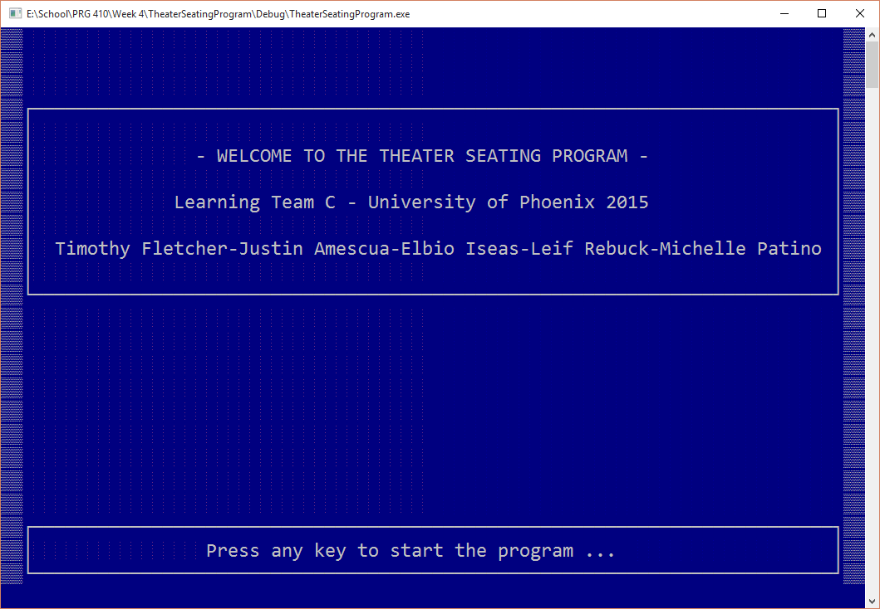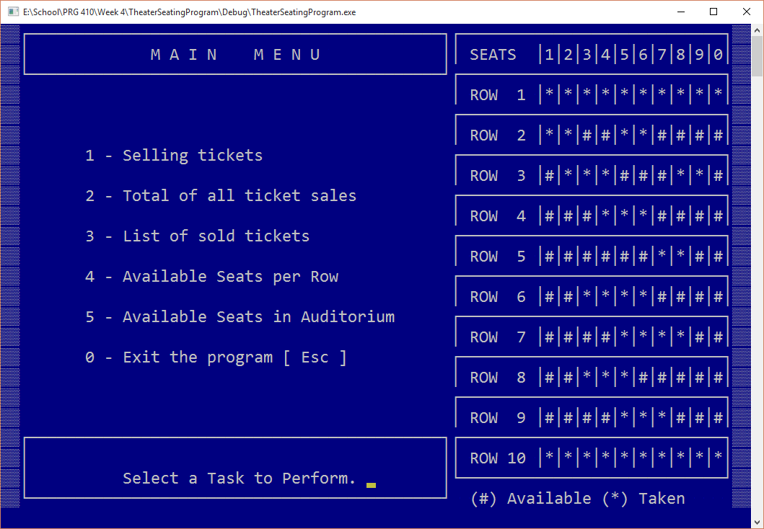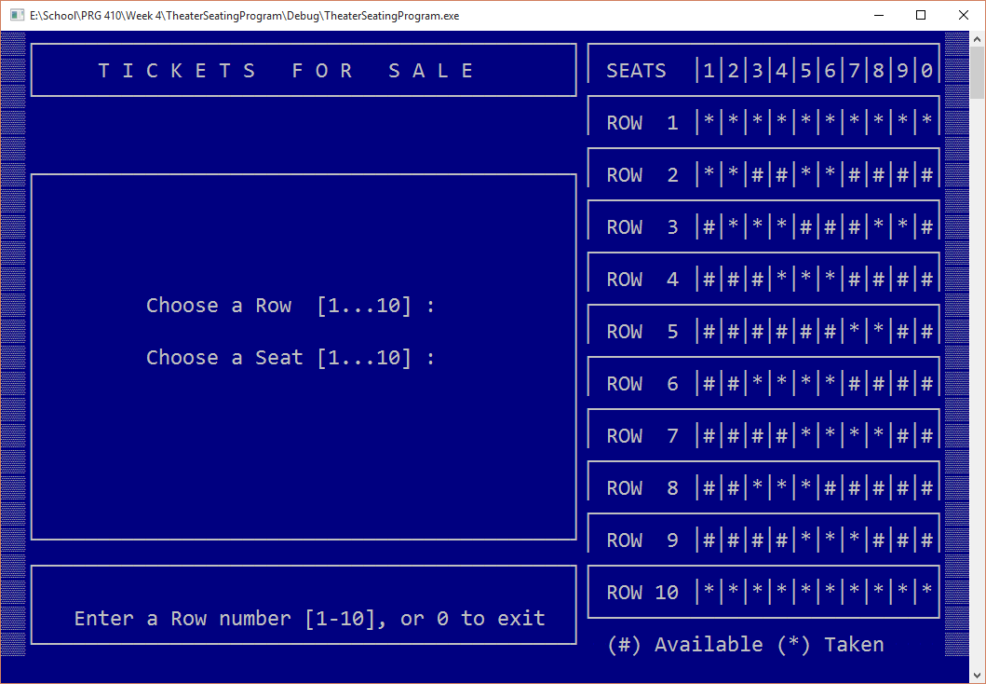
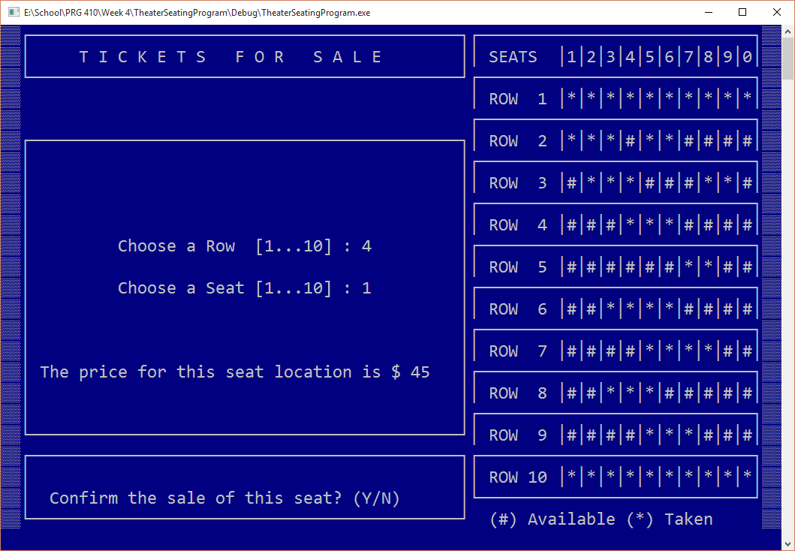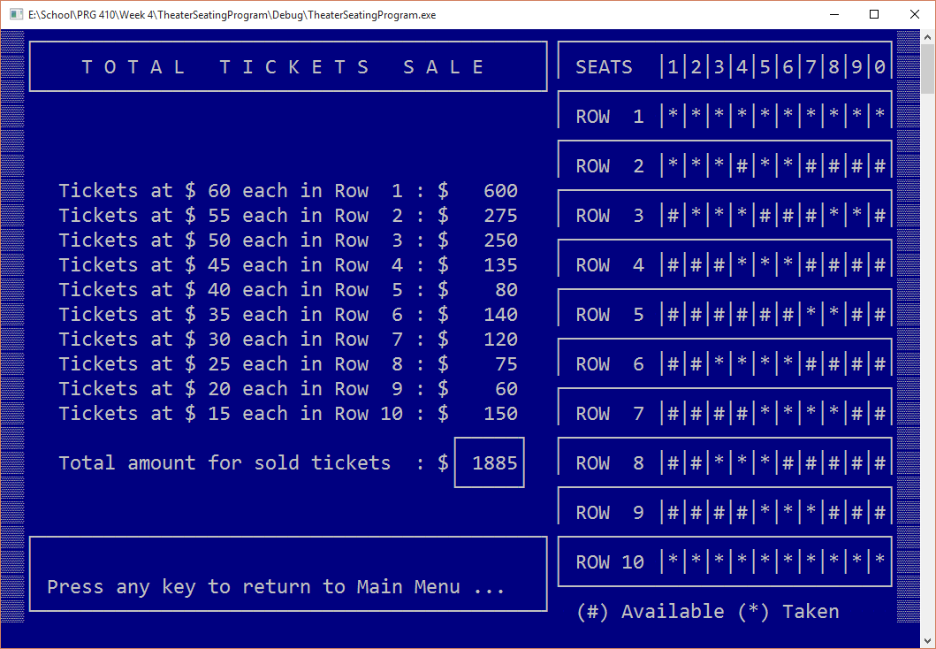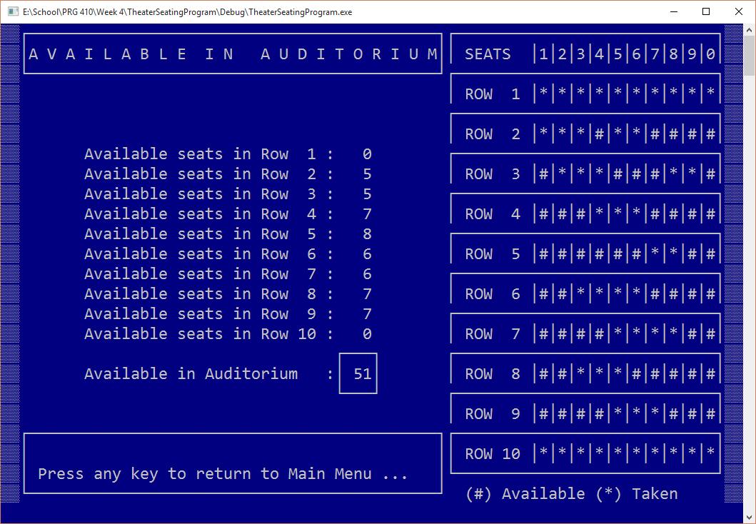
Testing:

Test 1: Does the program display the main menu? PASS.
Test 2: Does the all options of the main menu transition to the proper screen? PASS.
Test 3: Does the program properly terminate upon selection from the main menu? PASS.
Test 4: Does the program properly display the seating chart? PASS.
Test 5: Does the seating chart properly update when a seat is sold? PASS.
Test 6: Does the program properly display the cost of each row and seat? PASS.
Test 7: Does the program properly display and update the total ticket sales? PASS.
Test 8: Does the program properly display the available seats in the auditorium? PASS.

